Crazies Hill
C.E. Primary School

Determined Admissions Policy 2024-25

Committee Responsible: Staffing & Curriculum

Date of Next Review: Autumn Term 2023

Version | Date Reviewed | Changes | Date Approved
1 | May 2014 | New Policy | February 2020
2 | October 2021 | PAN wording and Overseas LAC wording as per Admissions Code 2021 | October 2021
3 | Nov 2021 | As per cycle | Nov / Dec 2021
4 | Oct 2022 | Updated as per ODBE guidance | February 2023

‘A tree is known by its fruit, people by their actions’
(based on Matthew 12 verse 33-5’)

Our vision at Crazies Hill CE Primary School is that our ‘fruit’ will be children and adults who have the resilience to weather life’s ups and downs, respect for themselves, others and their environment and the ability to build and maintain good relationships with all in their community. All our policies are written with this vision in mind.

Signed: Jo Shell, Head of School 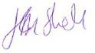

Signed: Lesley Turville, Chair of Governors 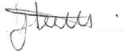

Crazies Hill Church of England Primary School

Admissions Policy for the Academic Year 2024-2025

The Keys Academy Trust, not Wokingham Local Authority (the LA), is responsible for determining admission arrangements to the school. The school is a partner in the coordinated admission arrangements for primary admissions in Wokingham LA and follows their admission timetable. This policy has been prepared by the Governing Body in consultation with the Keys Academy Trust and the Oxford Diocesan Board of Education and agreed with the relevant Admissions authorities and parents. The Governing Body has made every effort to ensure this policy complies with the School Admissions Code 2021 and all relevant legislation, including that on infant class sizes and equal opportunities.

Crazies Hill CE Primary School values highly its Christian ethos, its close links with local churches and the Diocese of Oxford. We provide a distinctively Christian, yet inclusive, environment in which each child is motivated to acquire skills for life and a love of learning.

As a church school, we welcome applications from Christian families, and those of other Faiths or none. We ask all parents applying for a place at our school to respect this ethos and its importance to the whole school community.

Admission arrangements to the Reception Year in September 2024

At our school, pupils are normally admitted at the beginning of the school year (1 September – 31 August) in which they reach their fifth birthday. Parents whose children were born between 1 September 2019 and 31 August 2020 may apply for them to be admitted to the Reception Year in September 2024. There are 15 places (the Published Admission Number (PAN) available. The Published Admission Number (PAN) only applies to the relevant age group. The relevant age group is the age group to which children are normally admitted. The school will refuse admission above this number as the admission of another child would prejudice the provision of efficient education or the efficient use of resources.

Parents of a child whose fifth birthday falls between 1 September 2024 and 31 March 2025 may defer entry until their child reaches compulsory school age (the term beginning in January or April after his or her fifth birthday). The school will hold the deferred place for the child (provided it is taken up during the school year 2024-25), although, in the majority of cases, we find that children benefit from starting at the beginning of the school year, rather than part way through it.

It is not possible to defer entry beyond the beginning of the term after the child’s fifth birthday nor beyond the year for which the original application was accepted.

For children whose fifth birthday falls between 1 April 2025 and 31 August 2025 (summer born children) parents can defer the date that their child is admitted to school but not beyond the point at which they reach compulsory school age ie the term after they reach their fifth birthday. If they wish their child to defer until September 2025, they should apply for a Year 1 place in September 2025.
Parents should be aware that the Year 1 group may have no vacancies and it could be full with children transferring from the 2024-25 Reception Year group.

Until the child reaches compulsory school age, s/he may attend part-time. If parents wish to exercise this right they should discuss detailed arrangements with the headteacher.

Parents (see Note 1) wishing to apply for the Reception Year in September 2024 must complete the common application form provided by their home local authority (the home LA). The home LA is the LA in whose area the parents live at the time of the application. The form must be returned to that LA no later than 15 January 2024. Applications received after this date will normally only be considered after all those received on or before the cut-off date. Offers and refusals of places will be posted by the home LA on 17 April 2024.

NOTE: Any of the information given on the application form may be verified, and the application re-categorized in the light of any inconsistencies.

Over-subscription criteria

Children with an Education Health and Care Plan (EHCP) or a Statement of Special Educational Needs naming Crazies Hill Church of England Primary School in the Plan or the Statement will always be offered a place.

If there are fewer applications than places available, all children will be offered places. If there is greater demand for admission than there are places available, the following criteria will be applied in the order set out below.

- Looked-after children and children who were previously looked after, but ceased to be so because, immediately after being looked after they became subject to an adoption, child arrangements or special guardianship order (See Note 2), including those children who appear to have been in state care outside England and ceased to be in state care as a result of being adopted.
- Families who have exceptional medical or social needs that make it essential that their child attends Crazies Hill CE Primary School rather than any other. These needs must be fully supported by written evidence from the appropriate professional person involved with the family. (See Note 3)

- Children with a normal home address (see Note 4) in the catchment area (see Appendix) and with a sibling (see Note 5) on the roll of the school at the time of application and who is expected still to be in attendance at the time of entry to the school.

- Children with a normal home address in the catchment area.

- Children with a normal home address outside the catchment area and with a sibling on the roll of the school at the time of application and who is expected still to be in attendance at the time of entry to the school.

- Other children.

Proximity of the child’s home, as measured by the straight-line distance (see Note 6) between the home and the school with those living nearer being accorded the higher priority, will serve to differentiate between children in criteria 1 to 6 should the need arise. In the event that two distance measurements are identical, the school will use random allocation to decide which child should be offered the place. The process will be conducted in the presence of a person independent of the school.

All other admissions

Admission to the school during the school year depends on whether or not there are places available. All year groups at the school have 15 places. Applications must be made to Wokingham Borough Council on a form available from that Council.
If there is a vacancy, and there is no child on the relevant waiting list with a higher priority (according to the over-subscription criteria 1-6 above), a place will be offered.

In Year admissions

In-year admissions or admissions at the beginning of school years other than Reception will only be considered up to half a term [using the three-term year] in advance of the desired date for entry. For example, for entry in January, the application will not be considered until after the October half term break.

Moving House

If parents are moving house, the school will ask for evidence of the move, when considering any application for a place. Documentary evidence in the form of a solicitor’s letter to confirm exchange of contracts, or a rental agreement for at least a period of six months will be required (Armed Forces personnel and crown servants returning from overseas are exempt – see note 4). If you are returning from elsewhere, to live in a home that you own, we will require evidence to show that you have returned. We will also ask for evidence that any previous house owned has been sold or is being sold. We would not accept an address where the one given is that of a second home with the main home being elsewhere. If there are two or more homes, we will check which is the main home, and may refuse to base an allocation of a place on an address which might be considered only temporary. Nor would we accept an address where the child was resident other than with a parent or carer unless this was part of a fostering or formal care arrangement. We would not normally accept an address where only part of a family had moved, unless connected with a divorce or permanent separation arrangement, in which case we would require proof.

Admission outside normal age group

Although most children will be admitted to the school within their own age group, requests from parents for school places outside their normal age group will be considered carefully eg. For those who have missed education due to ill health. Each case will be considered on its own merits and circumstances. However, such admissions will not normally be agreed without a consensus between the parents, the school, the LA and any relevant professionals asked for their opinion by the Governing Body that it is in the best interests of the child.
It is recommended that parents discuss their wishes with the head teacher in advance of applying for a place.

Waiting list

Waiting lists for Crazies Hill CE Primary School will be maintained by the local authority until the end of each academic year to fill places that may become available during the school year. No account is taken of the length of time spent on a waiting list. Positions on waiting lists may go up or down due to pupil withdrawals or new or revised applications received; therefore waiting lists will be reviewed and revised:

- Each time a child is added to, or removed from, the waiting list.
- When a child’s changed circumstances will affect their priority.
- When parents respond to periodic requests to see if they wish to remain on the waiting list.
- At the end of the school year, should there be a change in the determined over-subscription criteria.
Children who are the subject of a direction by the Local Authority to admit or who are allocated to a school in accordance with a Fair Access Protocol will take precedence over those on a waiting list. Parents will be able to apply online to Wokingham Borough Council for each year if they wish to be placed on the waiting list for that year. It is the responsibility of parents to ensure that the school admissions team is informed in writing if they want their child’s name to be removed from the waiting list or if their circumstances have changed from the original application.

A written offer will be sent to the most recent address provided for the child in question, and parents should note that if they do not accept the place by the date indicated in the letter (normally two weeks from the date of the letter), the place will be offered to the next name on the waiting list.

Multiple births or children with birth dates in the same academic year

In cases where there is one place available, and the next child on the list is a twin, triplet, etc., we would admit both twins (and all the children in the case of other multiple births) even if this meant exceeding the agreed admission number of 15 for Reception 2024-2025 or the number of places (15) in other year groups.

Fair Access

The school participates in the Wokingham Local Authority's Fair Access Protocol. This covers, for example, children who have moved into our area after the normal admission round, or who need to move school as a result of severe bullying or social issues. Children qualifying under the Fair Access Protocol may be offered a place even if there are no places available in the relevant year group and also take priority for admission over any child on the waiting list.

Appeals

Any parent not offered a place for their child has the right of appeal to an independent appeal panel, convened by the Oxford Diocesan Director of Education. Details are available from the school, including the date by which an appeal should be submitted. It should be noted that, in the event of an unsuccessful appeal against non-admission to the school, the school does not consider any further application in the same school year (1 September – 31 August), unless there has been a material change in circumstances, for example a change of address which results in a move from outside the catchment area to inside it.

It should be noted that if a place is requested outside the normal age group and is refused, but one in the normal age group is offered, then there is no right of appeal.

Admissions in September 2022/23
The school received 11 applications expressing a preference for admission to the
Reception Year in 2022 by the closing date in January 2022. These were ranked as follows:

Children with a statement or EHCP naming the school - 0
Criterion 1 - 0
Criterion 2 - 0
Criterion 3 - 3
Criterion 4 - 0
Criterion 5 - 5
Criterion 6 - 3
11 places were offered, all children eligible for a place at the school were offered a place.

Further information

Any requests for further information or to arrange a visit to the school should be addressed to the School.

Telephone number 0118 9402612
Email office@crazieshill.wokingham.sch.uk

NOTES

Terms used are as defined below:

Note 1 “Parent” is defined in law (The Education Act 1996) as either:

- any person who has ‘parental responsibility’ (defined in the Children Act 1989) for the child or young person; or
- any person who has care of the child or young person.

If you are in any doubt, please contact the school for advice.

Note 2 "Looked after" means a child in the care of a local authority or being provided with accommodation by a local authority in the exercise of its social services function. Previously looked after children are children who have been adopted, subject to child arrangement orders or special guardianship orders. Adopted children are those for whom an adoption order is made under the Adoption Act 1976 (Section 12) or the Adoption and Children Act 2002 (Section 46). A "child arrangements order" is one settling the arrangements to be made as to the person with whom the child is to live (Children Act 1989, Section 8, as amended by the Children and Families Act 2014, Section 14). A "special guardianship order" is one appointing one or more individuals to be a child’s special guardian/s (Children Act 1989, Section 14A). Internationally adopted, previously looked after children – IAPLC. These children now have the same priority as those looked after and previously looked after children in England.
A “looked-after child” includes any child who appears to have been in state care outside England if they were in the care of or were accommodated by a public authority, a religious organisation, or any other provider of care whose sole or main purpose is to benefit society.
Applications under this criterion must be accompanied by evidence to show that the child is looked after or was previously looked after (e.g. a copy of the adoption, child arrangements or special guardianship order).

Note 3 When applying under this criterion (exceptional medical or social needs), you must include supporting evidence from an independent professional person who is aware of the situation and supports your reasons for preferring Crazies Hill CE Primary School. This supporting evidence must clearly demonstrate why the school is the most suitable and must illustrate the difficulties that would be caused if your child had to attend another school. The person supplying the evidence should be a doctor, health visitor, social worker, etc. who is aware of your child’s or your own case. The school reserves the right to ask for further evidence or clarification where necessary and may seek the advice of appropriate educational professionals where necessary.

Note 4 "Normal home address" means the child’s home address. This must be where the parent or legal carer of the child lives with the child unless it is proved that the child is resident elsewhere with someone else who has legal care and control of the child. The address should be a residential property that is owned, leased or rented by the child’s parent/s or person with legal care and control of the child.

To avoid doubt, where a child lives with parents with shared responsibility, each for part of a week or month, the address where the child lives will be determined having regard to a joint declaration from the parents stating the exact pattern of residence. If the residence is not split equally, then the relevant address used will be that at which we are satisfied that the child spends the majority of the school week. Where there is an equal split or there is any doubt about residence, we will make the judgment about which address to use for the purpose of determining whether or not to offer a place. We will take into account, for example, the following:

- any legal documentation confirming residence
- the pattern of the residence
- the period of time over which the current arrangement has been in place
- confirmation from any previous school of the contact details and home address supplied to it by the parents
- where the child is registered with his/her GP
- any other evidence the parents may supply to verify the position.

We may ask for evidence of the normal home address in the form of a recent bill. This could be, for example, the most recent Council Tax bill, utility bill no more than three months old, a current TV license, buildings and contents insurance, mortgage statement or rent book which shows the address concerned. Parents who are unable to provide this evidence should contact the school to discuss what evidence might be acceptable. If it becomes clear or if there is any doubt that the parents and child are not living at the address given on the application form, the school may seek further evidence. The school works closely with the LA to ensure that places are not obtained at the school on the basis of false addresses, and, in cases of doubt, will take steps to verify the information provided. If a place at the school is offered, and it later becomes clear that the offer was made on fraudulent or misleading information (e.g. a false claim to living in the catchment area), and the school has denied a place to a child with a stronger claim, the school will withdraw the offer of a place. The offer can also be withdrawn even after the child has started at the school.

We regard a child’s home address to be where he or she sleeps for the majority of the school week (Monday to Friday). We may ask to see official documentation, such as a child benefit book or medical card if there are reasons why a child does not live at his or her parent’s address. For example, if he or she is resident with a grandparent, this needs to be made clear on the application form. If such arrangements are not declared or a relative’s address is used on the application, we may consider that a false declaration has been made, and withdraw the offer of a place. Childcare arrangements are not sufficient reason for listing another address.

If parents move house after the application has been made, but before any offer of a place has been made, the home LA must be informed.

If parents are moving, we will ask for evidence of the move when considering any application for a place.

We would not accept an address where the one given is that of a second home with the main home being elsewhere. If there are two or more homes, we will check which is the main home, and may refuse to base an allocation of a place on an address which might be considered only temporary. Nor would we accept an address where the child was resident other than with a parent or carer unless this was part of a fostering or formal care arrangement. We would not normally accept an address where only part of a family had moved, unless connected with a divorce or permanent separation arrangement, in which case we would require proof.

There are special arrangements for families of service personnel with a confirmed posting or crown servants returning from overseas. If the application is accompanied by an official letter that declares the relocation date, and if there is a place available, it will be offered even though there is not an intended address or the family is not yet living in the area.

Note 5 "Sibling" means brother or sister, half brother or sister, adopted brother or sister, step brother or sister, or the child of the parent/carer’s partner, where the child for whom the school place is sought is living in the same family unit at the same address as that sibling. It is helpful if parents make it clear on the application form if the sibling has a different family name. When there is more than one sibling at the school, only the youngest need be listed on the application form.

Note 6 If there are more applicants within each criterion, radial (straight line) distance from home to school will be used as a tie-breaker and will be measured using the local authority’s computerised geographical information system. The Council has a standard method of measuring home to school distance in a straight line using the LLPG (Land and Property Gazetteer) eastings and northings to measure the distance between the address point of the child’s home address and the agreed point at the school. For applicants who live the same distance from the school, random selection by the drawing of lots is used as a final tie-breaker.

Appendix

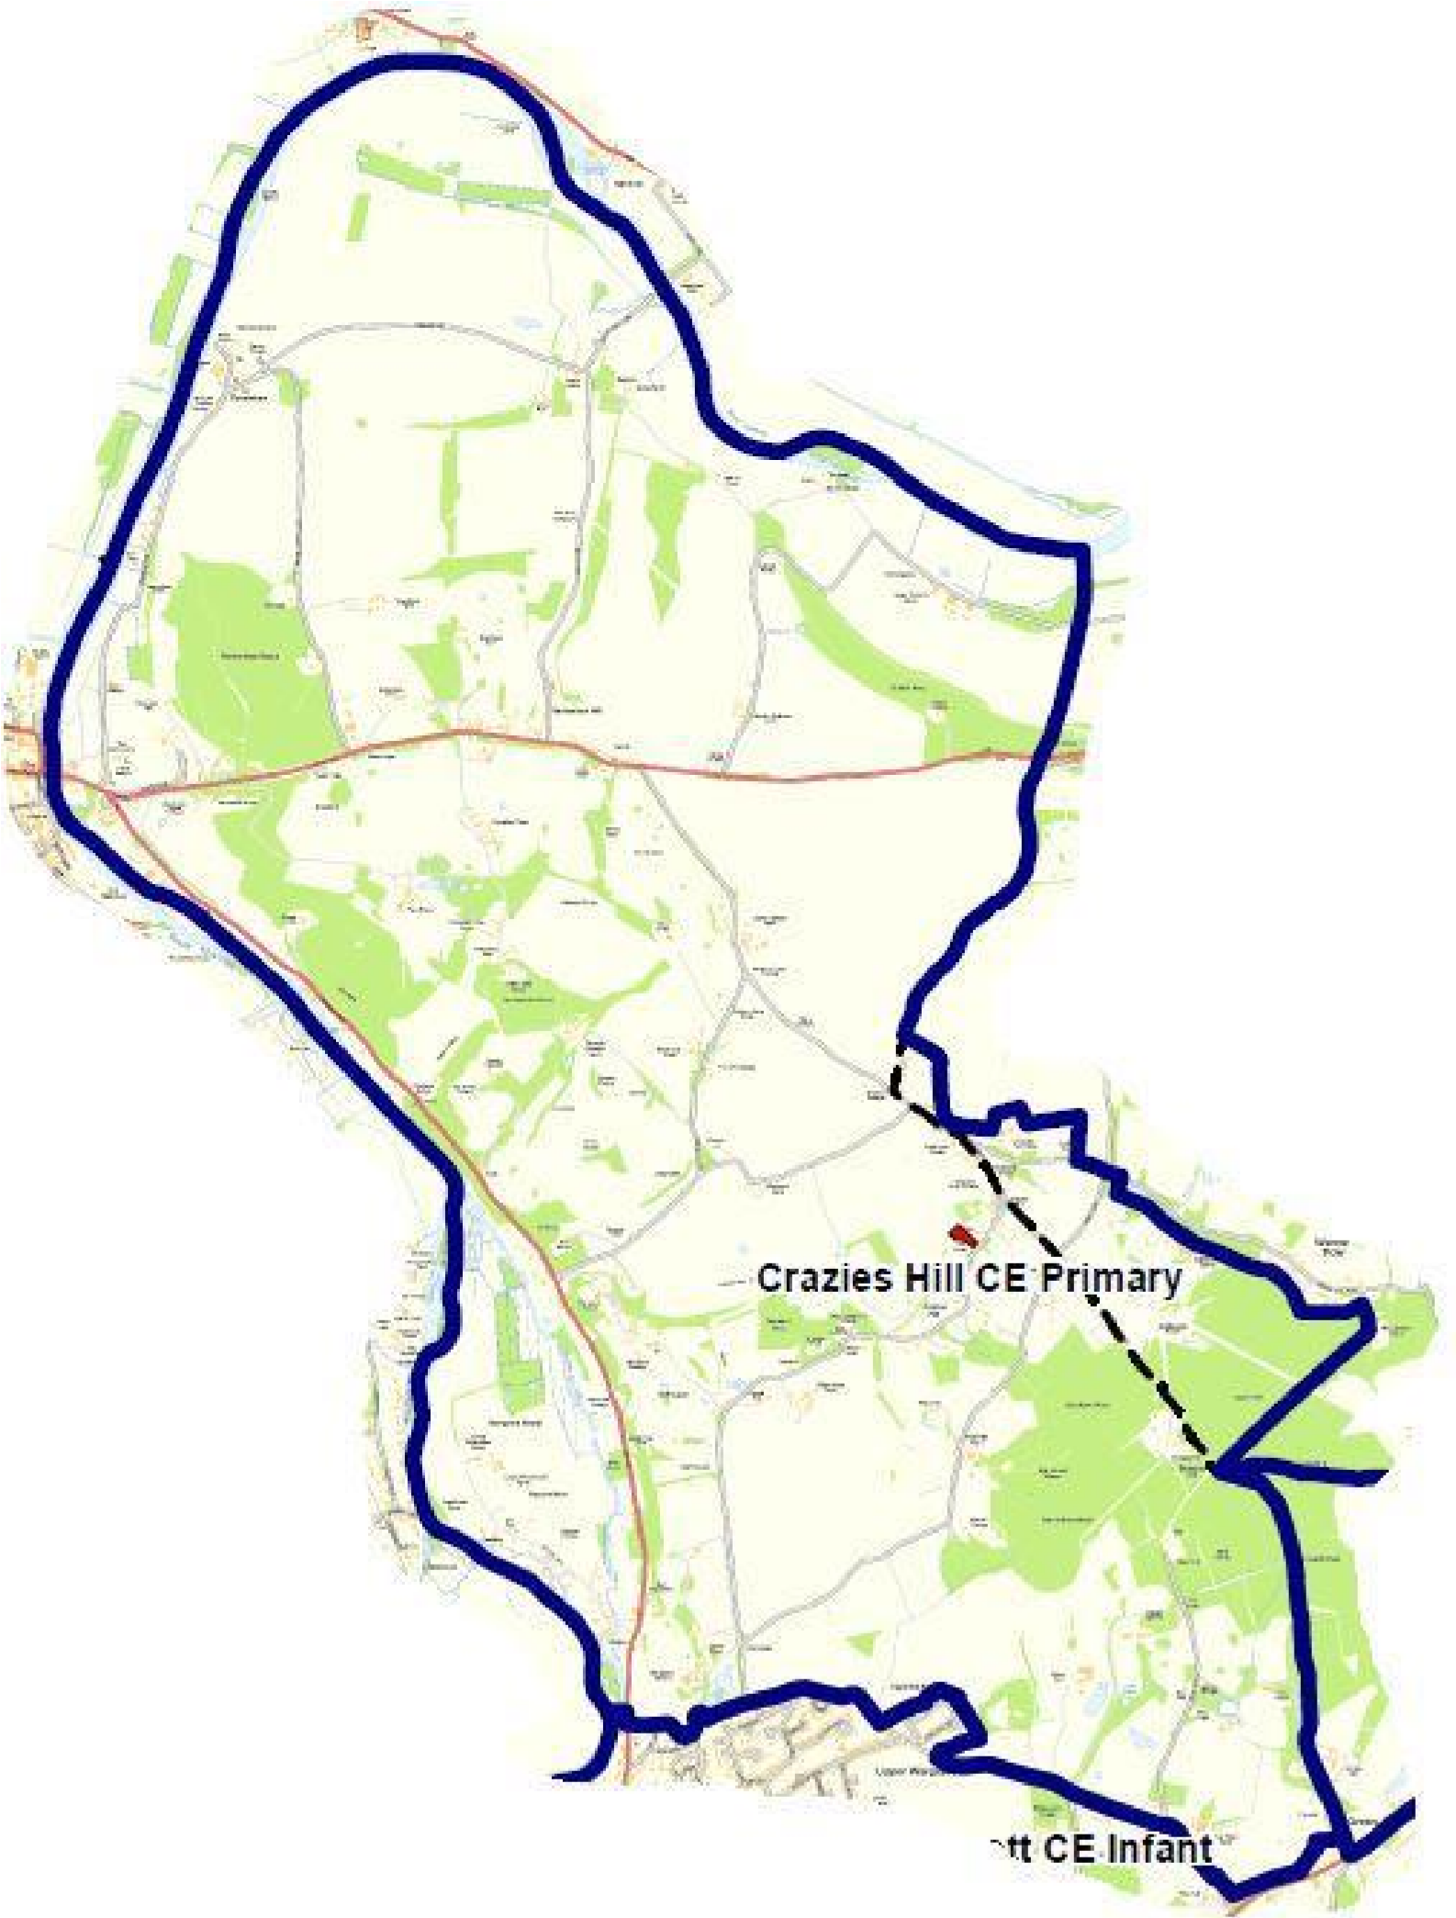
Catchment

area map

